Rumson Amusement Equipment Pty LTD
Park Rides Manufacturer Catalogue/Pricelist.

Email: sales@rumson-rides-inflatables.co.za Landline: +27-215-160-035
Website: www.rumson-rides-inflatables.co.za WhatsApp: +27-834-934-994
Product Name | Picture | Capacity | Description | Factory Price
Christmas Express Train | 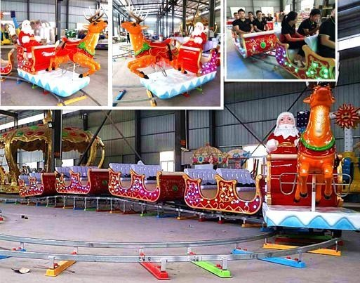 | 18 seat | Model: RBHC-18(patent ride)  Capacity: 18P ,5  Cars (Including the front)  Carriage：1.77*1.01*0.87m  Locomotive：  2.71*1.03*1.85m  Motor：5sets/600w/36v  Power：3kw | R 103,500
26 Seat Royal  Crown Carousel | 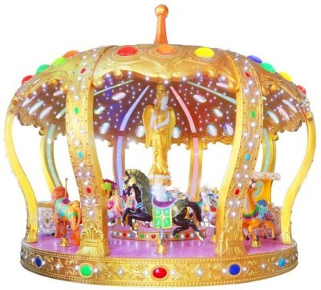 | 26 seat | Area: 6m*12m  Model: RBFH-26(patent ride)  Voltage:380V Power:10kw  Diameter:8.3m  Height:6.6m  Capacity:26 seat | R 522,000
12 Seat Royal  Crown Carousel | 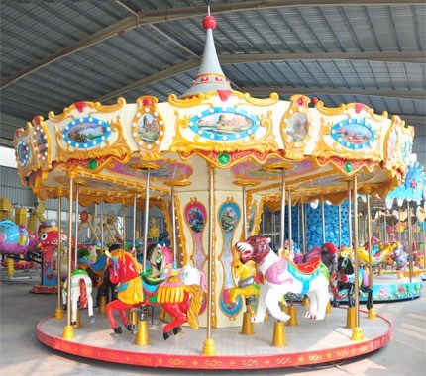 | 12 seat | Model: RBFH-12(patent ride)  Voltage:380V Power:4kw  Diameter:5m  Height:4m  Capacity:12 seat | R 183,000
Macaron  Carousel | 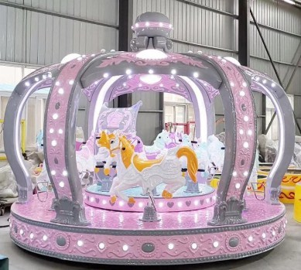 | 12 seat | Model: RBFH-12(patent ride)  Voltage:380V Power:4kw  Diameter:5m  Height:4m  Capacity:12 seat | R 198,000
Tourist Bus | 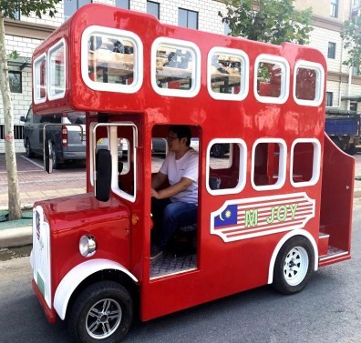 | 16/20 seat | Model:RBBS-16-20 Dimention:  L3250*W1390*H2472MM  VOLTAGE: 220V  POWER:3.5KW  CAPACITY: 10adults(20kids)  SPEED:5rp/h  Weight:1100KGS CBM: 26cbm | R 135,000

Royal Crown  Carousel  6-7seats | 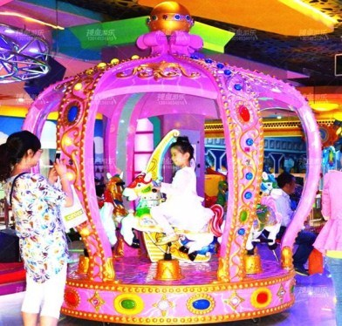 | 6-7seats | Model:MMRM-06  Material:FRP + GB steel  Capacity: 6/7P  Power:1.5kw  Voltage:220V  Dimension:D2.2m*H2.95m  Weight:550KGS（6seats) | R 72,000
16seats Luxury  Carousel | 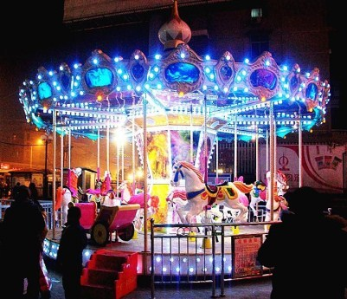 | 16 seat | Model:RM-16 Capacity:16 seat  Diameter:6.5m  Height:5.8m  Power: 4kw  Voltage: 380V | R 127,500
24seat  Carousel(24sea  ts) | 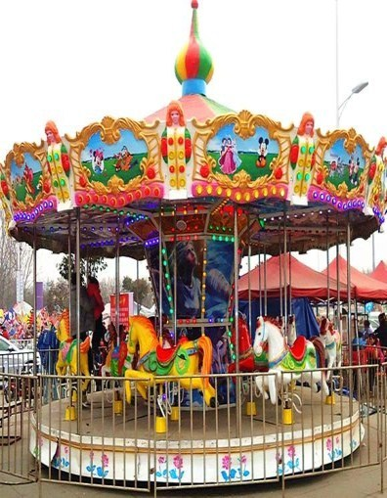 | 24 seat | Model:RM-24  Diameter:9m  Speed:4-5r/min  Power:7KW  Voltage: 380V  W:2.5T  CBM: 35CBM | R 228,000
Travel The  Wandering  Earth | 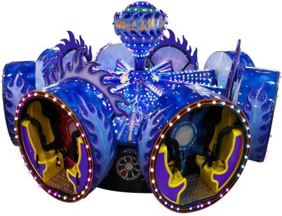 | 16 seat | Model:LLFR-16(patent ride)  Patent ride  Voltage:380V Power:10kw  Diameter:6.6m  Height:3m  Capacity:16seat | R 351,000
Interstellar  Hawk | 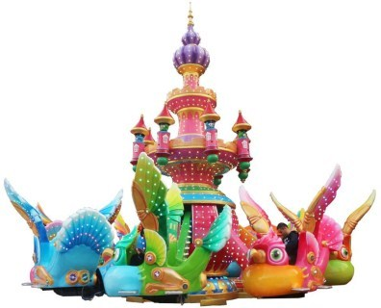 | 32 seat | Model:XJRK-32(patent ride)  Voltage:380V Power:12kw  Diameter:10m  Height:6m  Capacity:32 seat | R 753,000
Interstellar  Adventure | 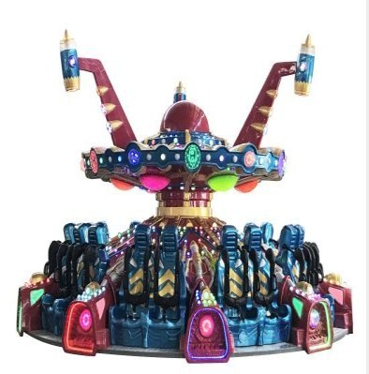 | 20 seat | Model:XJDMX-20(patent ride)  Voltage:380V Power:13kw  Diameter:8.5m  Height:5.3m  Capacity:20 seat | R 483,000

Interstellar  Adventure | 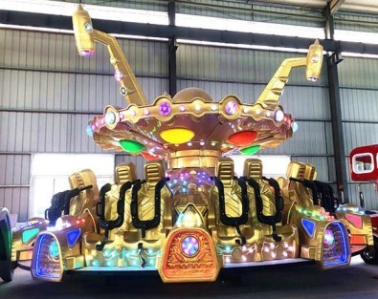 | 20 seat | Model:XKDMR-20(patent ride)  Voltage:380V Power:13kw  Diameter:8.5m  Height:5.3m  Capacity:20 seat | R 483,000
Lollipop  Rotation  Bungee | 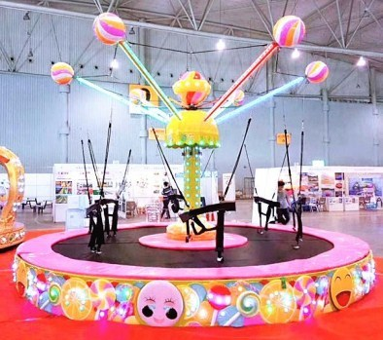 | 6 seat | Model:TRFR-06(patent ride)  Voltage:220V Power:1.5kw  Diameter:6m  Height:3.5m  Capacity:6 seat | R 117,000
Ocean Adventure | 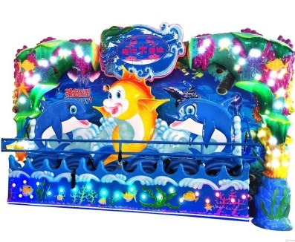 | 6 seat | Model:KYDMR-06(patent ride)  Voltage:380V  Power:10kw  Dimension With  Fence:6.5*3.3  Capacity:6seat Height:3.1m | R 127,500
Interstellar  Hawk | 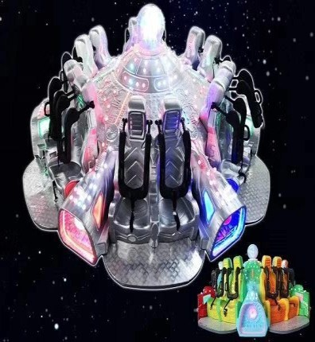 | 12 seat | Model:STRFT-12(patent ride)  Voltage:380V Power:8kw  Diameter:6m  Height:2.2m  Capacity:12seat | R 211,500
Happy Nori | 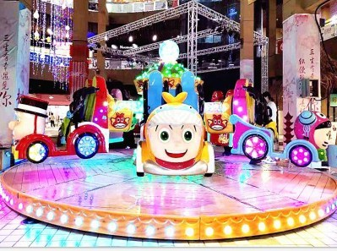 | 12 seat | Model:KRLL-12(patent ride) Voltage:380V/Power:10kw  Diameter:6.3m/Height:2.8m Capacity:12seat | R 258,000
Piral Jet | 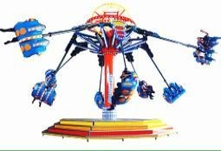 | 16 seat | Model:KRSJ-12  Voltage:380V Power:12kw  Diameter:7m  Height:5m  Capacity:12seat | R 291,000

Super Swing | 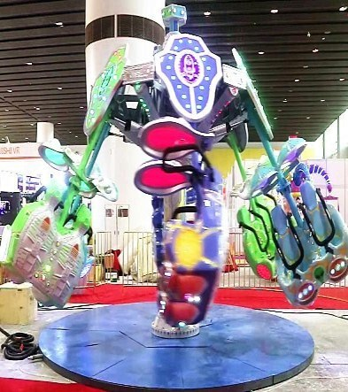 | 16seat | Model:KRFR-12(New Ride)  Voltage:380V  Power:12 kw  Diameter:7 m  Height:5 m  Capacity:12 seat | R 291,000
Monkey King Playing Water | 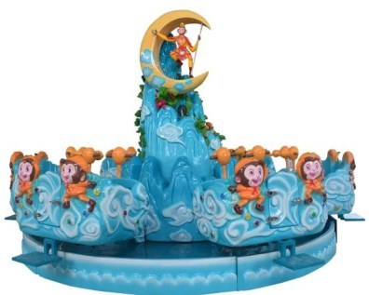 | 12 seat | Model:HWRS-12  Voltage:220V Power:1.5kw  Diameter:6m  Height:3.2  Capacity:12seat | R 147,000
Robot Ferris  Wheel | 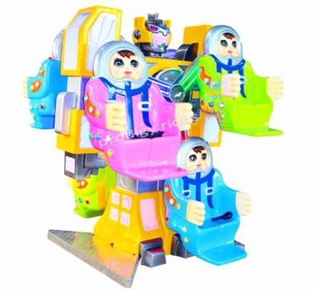 | 6 seat | Model:JRRMTL-03  Voltage:380V  Power:4kw  Dimension:2.3*2.1*3(m)  Capacity:6 seat | R 89,700
Monkey King | 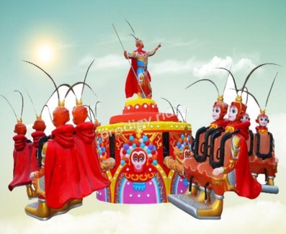 | 12 seat | Model:RWTT-12  Voltage:380V Power:5kw  Diameter:6.8m  Height:3.7m  Capacity:12seat | R 237,000
Self-control  Plane | 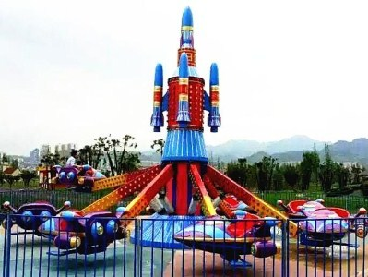 | 16 seat | Model:RKFJ-16-01  Voltage:380V  Power:11.5kw  Diameter:10m  Height:4.5m  Capacity:16seat | R 157,500
Self-control  Plane | 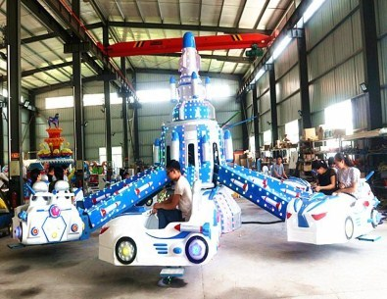 | 16 seat | Model:RKKJ-16  Voltage:380V  Power:11.5kw  Diameter:10m  Height:4.5m  Capacity:16seat | R 157,500

Prodigy Robot | 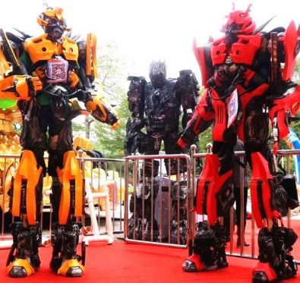 |  | Model;JMTR  Weight:35kg  Volume after package:1200*900*900(mm) Height:2.8m  Weight after package:40kg | R 11,700
Sweet Candy  Flying Chair | 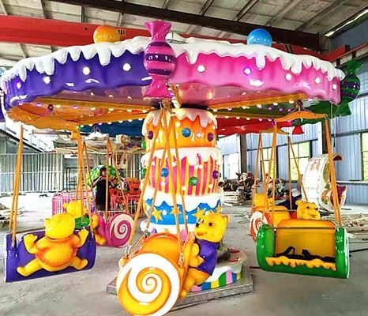 | 12 seat | Model:TGFR-12  Voltage:220V  Power:1.5kw  Diameter:4.5m  Height:2.5m  Capacity:12seat | R 90,000
Fruit Flying  Chair | 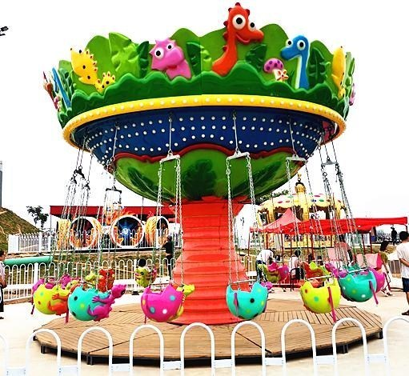 | 16 seat | Model:SGFR-16  Capacity:16P  Power:8.5KW  Voltage:380V  Dimension: D6m*H5.5m | R 157,500
Giraffe flying chair | 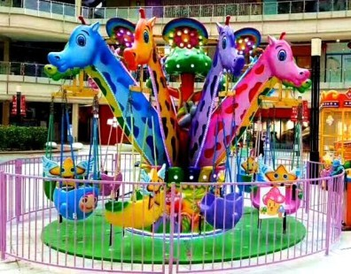 | 12 seat | Model:CILFR-15  Size: D5mxH3.3m  Capacity: 15P  Power: 3KW  Voltage: 380V, 50/60HZ  Speed: 4rpm  Space area: 6x6m | R 114,000
Happy Flying  Chair | 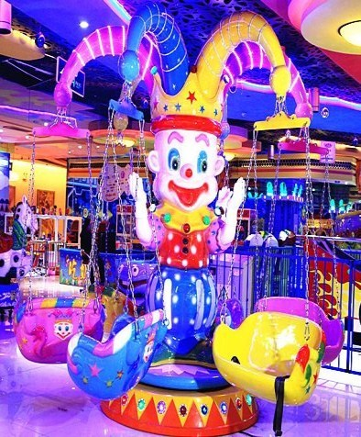 | 12 seat | Model:HLFR-12  Voltage:220V/Power:1.5kw  Diameter:4.2m/Height:2.6m Capacity:12seat | R 60,750
Prodigy Rotary  Plane | 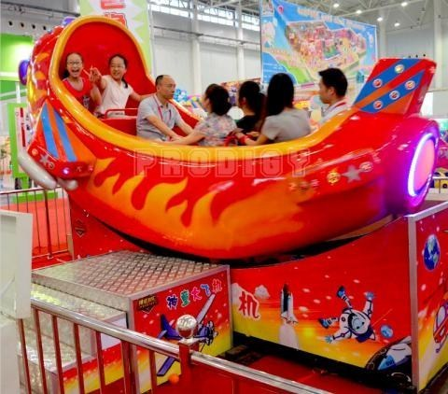 | 10 seat | Model:RMFJ-10  Capacity: 10P  Power:6.5KW  Voltage: 380V  Dimensions:L6m*W5m*H2.8 m Weight: 2490KGS | R 87,000

Crazy Plane | 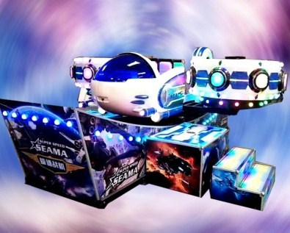 | 12 seat |  | Model:RKFK-12  Material: firberglass  Capacity: 12P  Area: 6m*9m  Voltage:380V  Power:8KW |  | R 138,000
Mini Flying Car | 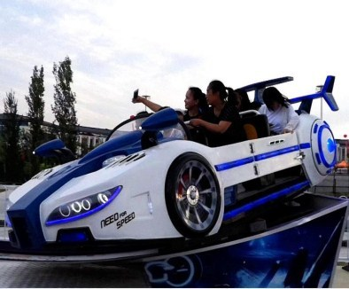 | 12 seat |  | Model:MMFR-12  Voltage:380V  Power:6kw  Dimension:8*6*2.8(m) Capacity:12seat |  | R 89,550
Mini pendulum | 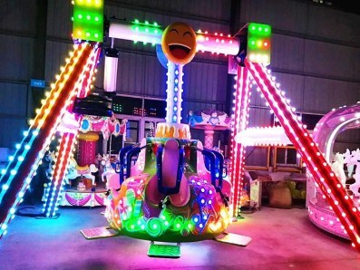 | 6 seat |  | Model:RBC-06  Voltage:380V  Power:6kw  Dimension:5*5*3.5(m) Capacity:6seat |  | R 112,500
Mini Disco  Tagada | 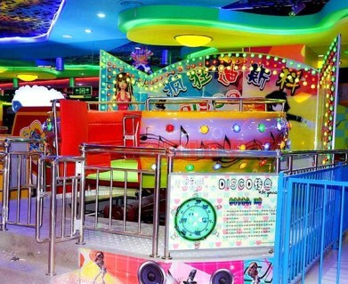 |  | 14 seat |  | Model:DSKRP-14  Voltage:380V  Power:8kw  Dimension:L4.6*W4.2*H2.7 m Capacity:14seat | R 118,500
Disco Tagada | 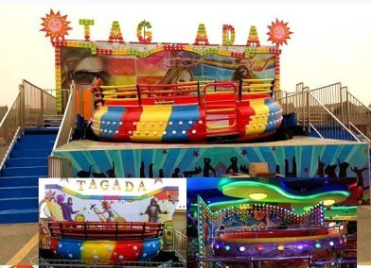 |  | 24 seat |  | Model:DSKRP-24  Voltage:380V  Power:20kw  Dimension:15*13(m) Capacity:24seat | R 277,500
Crazy Miami  Rides | 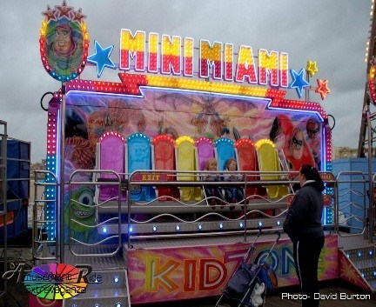 | 8 seat | Model:RAR-10  Voltage:380V Power:10kw  Size:7m*9m  Height:3.5m  Capacity:10seat | R 295,500
Shaking Head  Flying Chair | 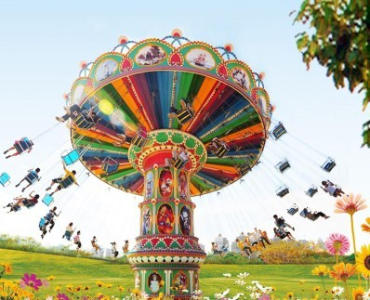 | 24 seat | Model:RTFR-24  Voltage:380V Power:15kw  Diameter:13m  Capacity:24seat | R 351,000
Elephant Train | 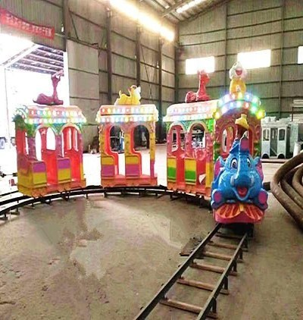 | 14 seat | Model:DRHC-14  Capacity:14P  Power: 3KW 220V  Speed:3.5rpm  Cover area:10*8m Packing size:  22CBM,1200KGS | R 93,000
Ocean Train | 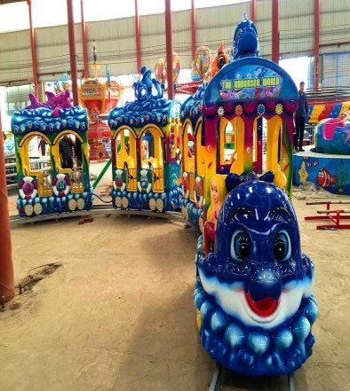 | 14 seat | Model:DRHC-14  Voltage:380V/Power:1.5kw  Dimension:5*5*3m Capacity:14seat | R 97,500
Trackless train | 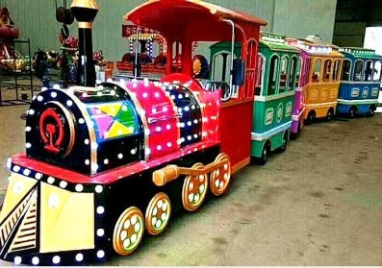 | 14seat | Model:SRHC-14 locmotive+4carriage Locomotive：  300*110*200cm  Carriage：163*110*200cm  Voltage：60V  Power：4kw | R 135,000
Trackless train  （ModelB) | 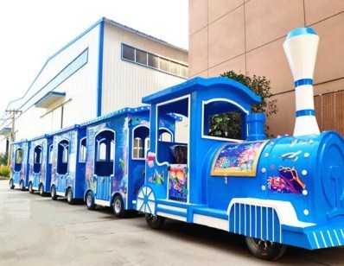 | 14 seat | Model:RSKC-02  Locomotive：3.1*1.66*2.4(m)  Carriage：2.3*1.5*2.1(m) Voltage：192V  Power：1.2kw Capacity:14 | R 135,000

Trackless train | 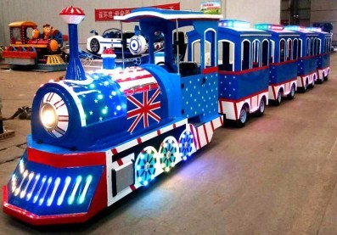 | 14 seat | Model:SRHC-02  Locomotive：262*111*156cm  Carriage：254*95*106cm  Voltage：192V  Power：1.2kw Capacity:14 | R 135,000
Ocean Trackless train | 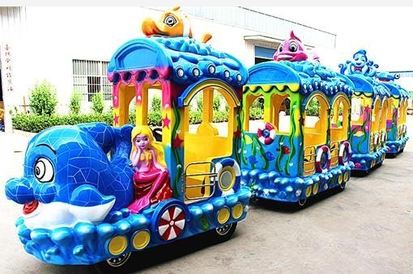 | 14 seat | Model:SRHC-03 Locomotive：  240*125*200cm  Carriage：230*120*200cm  Voltage：48V  Power：2.2kw  Running time：10-12h | R 112,500
 |  |  | Capacity 14P
Trackless Train | 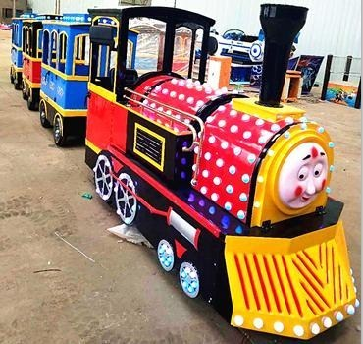 | 14 seat | Model:SRHC-02  Voltage:60V  Power:3kw  Dimension:3*1.3*2.02(m) Capacity:14seat | R 135,000
Spray a Cart | 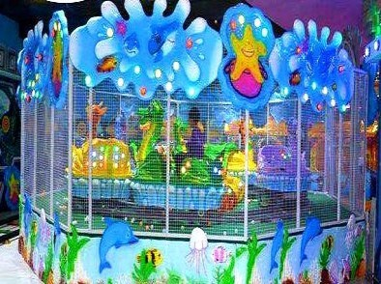 | 8 seat | Model:PBC-8  Capacity: 8P  Power:6.5KW  Voltage: 380V Dimensions:  L9m*W5m*H2.8m | R 82,500
Small Track  Train | 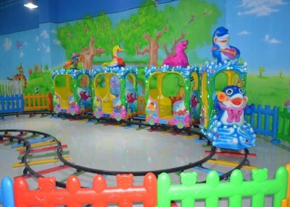 | 12seat | Model：RDHC-05  Voltage:220V  Power:1.2 kw  Size with fence:6m*6m*2.5m Capacity:5 seat | R 60,000
Orient Express  Train | 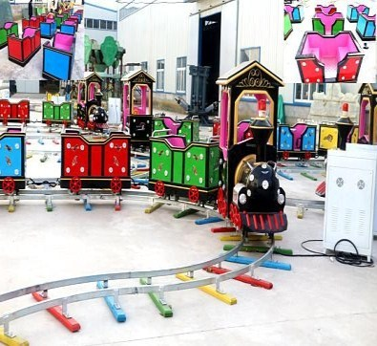 | 14 seat | Model:RRKC-14  Voltage:220V  Power:1.5kw  Dimension:5*5*3m Capacity:14seat | R 69,000
Mini Shuttle | 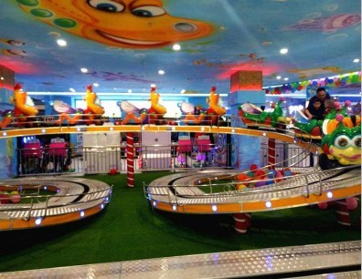 | 20 seat | Model:MNRS-20  Voltage:380V  Power:10kw  Dimension:10m*16m Capacity:20seat | R 247,500

Mini Pirate Ship | 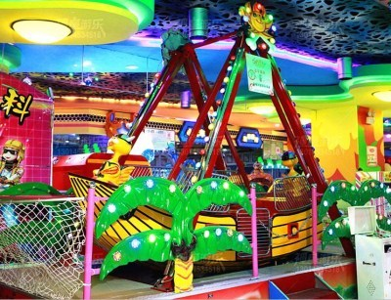 | 12 seat | Model:MNHRC-08  Voltage:380V  Power:3kw  Dimension:3m*5m Capacity:8seat | R 85,500
24 seat Pirate  Ship | 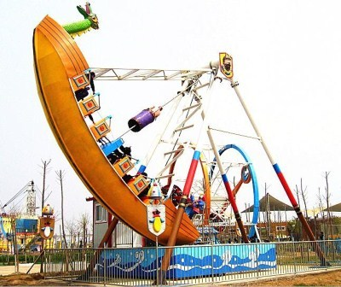 | 24 seat | Model:RDC-24  Voltage:380V Power:13kw  Dimension:10m*12m  Height：9m  Capacity:24seat | R 233,700
40 seat Pirate  Ship | 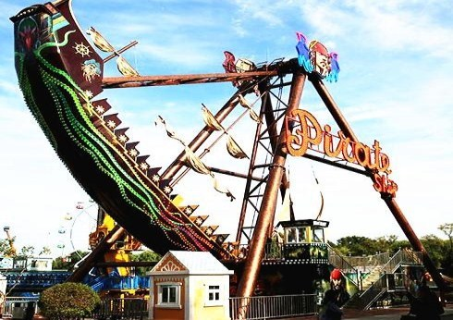 | 40 seat | Model:RDC-40  Capacity:40P  Power: 15KW Voltage: 380V Dimension:  L14.8m*W8m*H11m Cover  area: 7m*8m  Cover area(with fence):  10m*12m | R 340,500
Mini Ferris  Wheel | 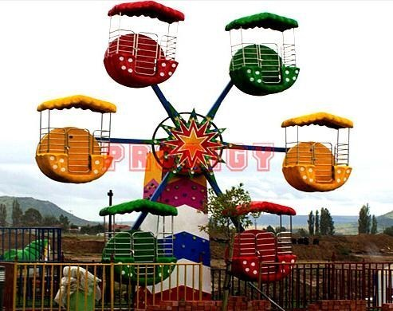 | 12 seat | Model:MNRLC-12  Voltage:380V Power:3kw  Demeter:6.5m  Height:8m  Capacity:12seat | R 148,500
Bumper Car | 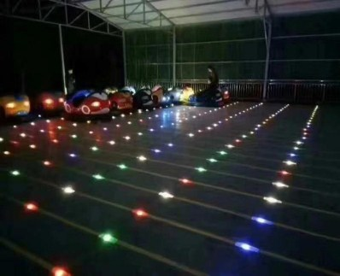 | 2 seat | Model:Electrical  Dimension:1920*1080*880( mm)  Capacity:2seat | Unit Car  Price: R14,700  Floor Price: R975/㎡  Control box: R21,000
Bumper Car | 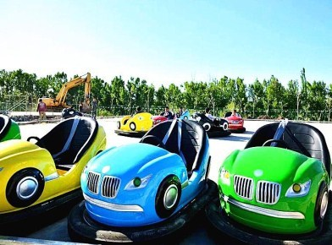 | 2 seat | Model:battery  Dimension:1920*1080*880( mm)  Capacity:2seat | R 14,250/set
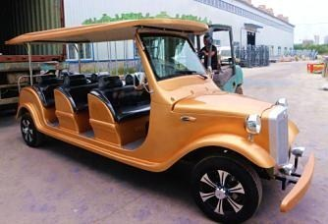
Classic Car |  | 8 seat | Model:JDC-08 Dimension:  L5040*W1550*H1970mm | R 108,000
Prodigy car | 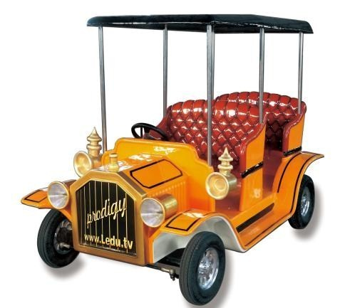 | 4 seat | Model:LRC-04 Dimension:  L2550*W1470*H1850mm  Voltage:48V  Power: 3KW  Capacity: 6P | R 75,000
Happy lewing car | 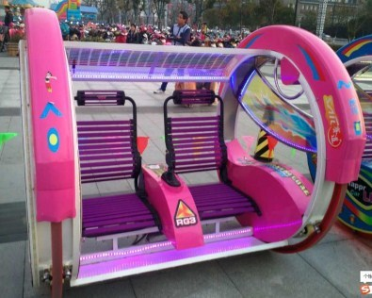 | 2 seat | Model:BRC-02  Capacity:2P  Power:120W(2pcs)  Weight:160kgs  Loadding weight:310kgs Speed:6km/h | R 18,300
360 degree rotation be bar  car | 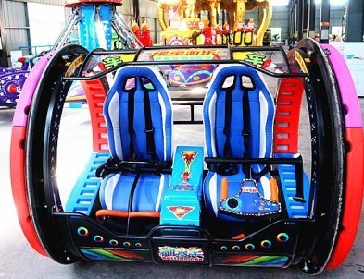 | 2 seat | Model:RBC-01  Size:L1400*W1750*H1400m  m Weight: 250KGS Power: 2*300W(2 motors)  Battery: 48V, 20Ah  Color: Yellow, Blue, Red, Pink  Max Load:200kgs | R 45,000
Small jelly fish  Ride | 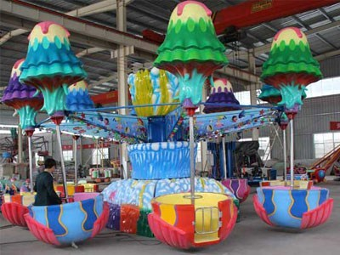 | 6 seat | Model:RKSY-06  Capacity:6-8P  Power: 1.5KW  Voltage: 220V  Dimension: D5m*H2.5m | R 81,000
Ladybugs Park | 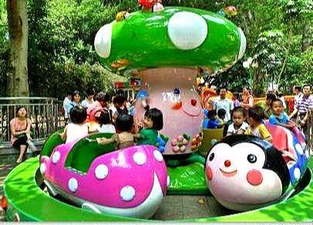 | 20 Seat | Model:PCRY-12  Capacity:12P  Power: 3KW  Voltage: 220V  Cover area: D3.5m | R 108,000
Ocean Walking | 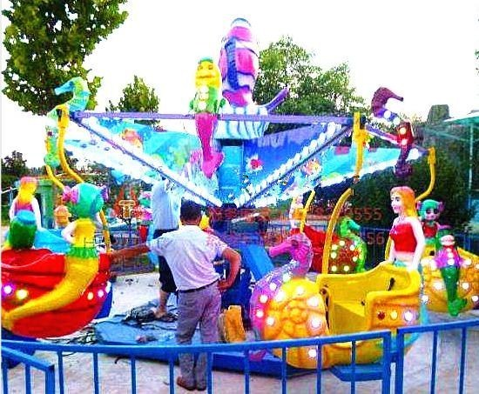 | 12 seat | Model:RYSB-12  Capacity:12P  Power: 4.5KW  Voltage:380V  Dimension: D5m*H2.5m | R 93,000
Motor Arena | 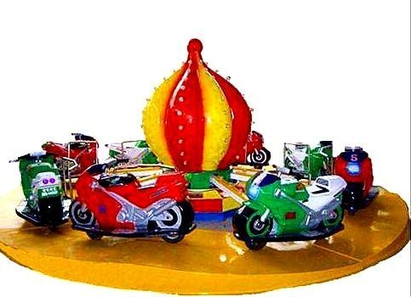 | 12 seat | Model:RTDD-12  Capacity:12P  Power: 2.5KW  Voltage:220V  Dimension: D5m*H2.8m | R 93,000
Bull Rides | 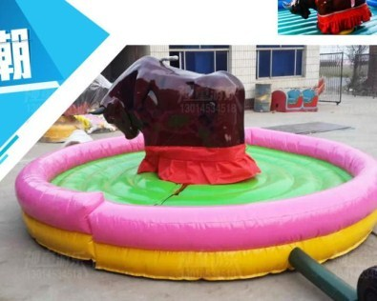 |  | Model：BNR-11  Area diameter：5m  Voltage:220V  Power:1.5kw Cargo volume:3.5CBM | R 30,000
Ferris ring car | 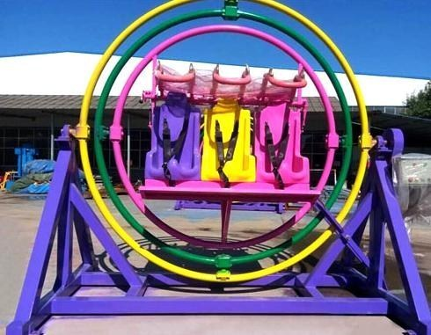 | 6 Seat | Model:RKS-06  Power:3kw  Voltage:380V  Capacity:6 seat  Area:3.6m*3.6m | R 60,000
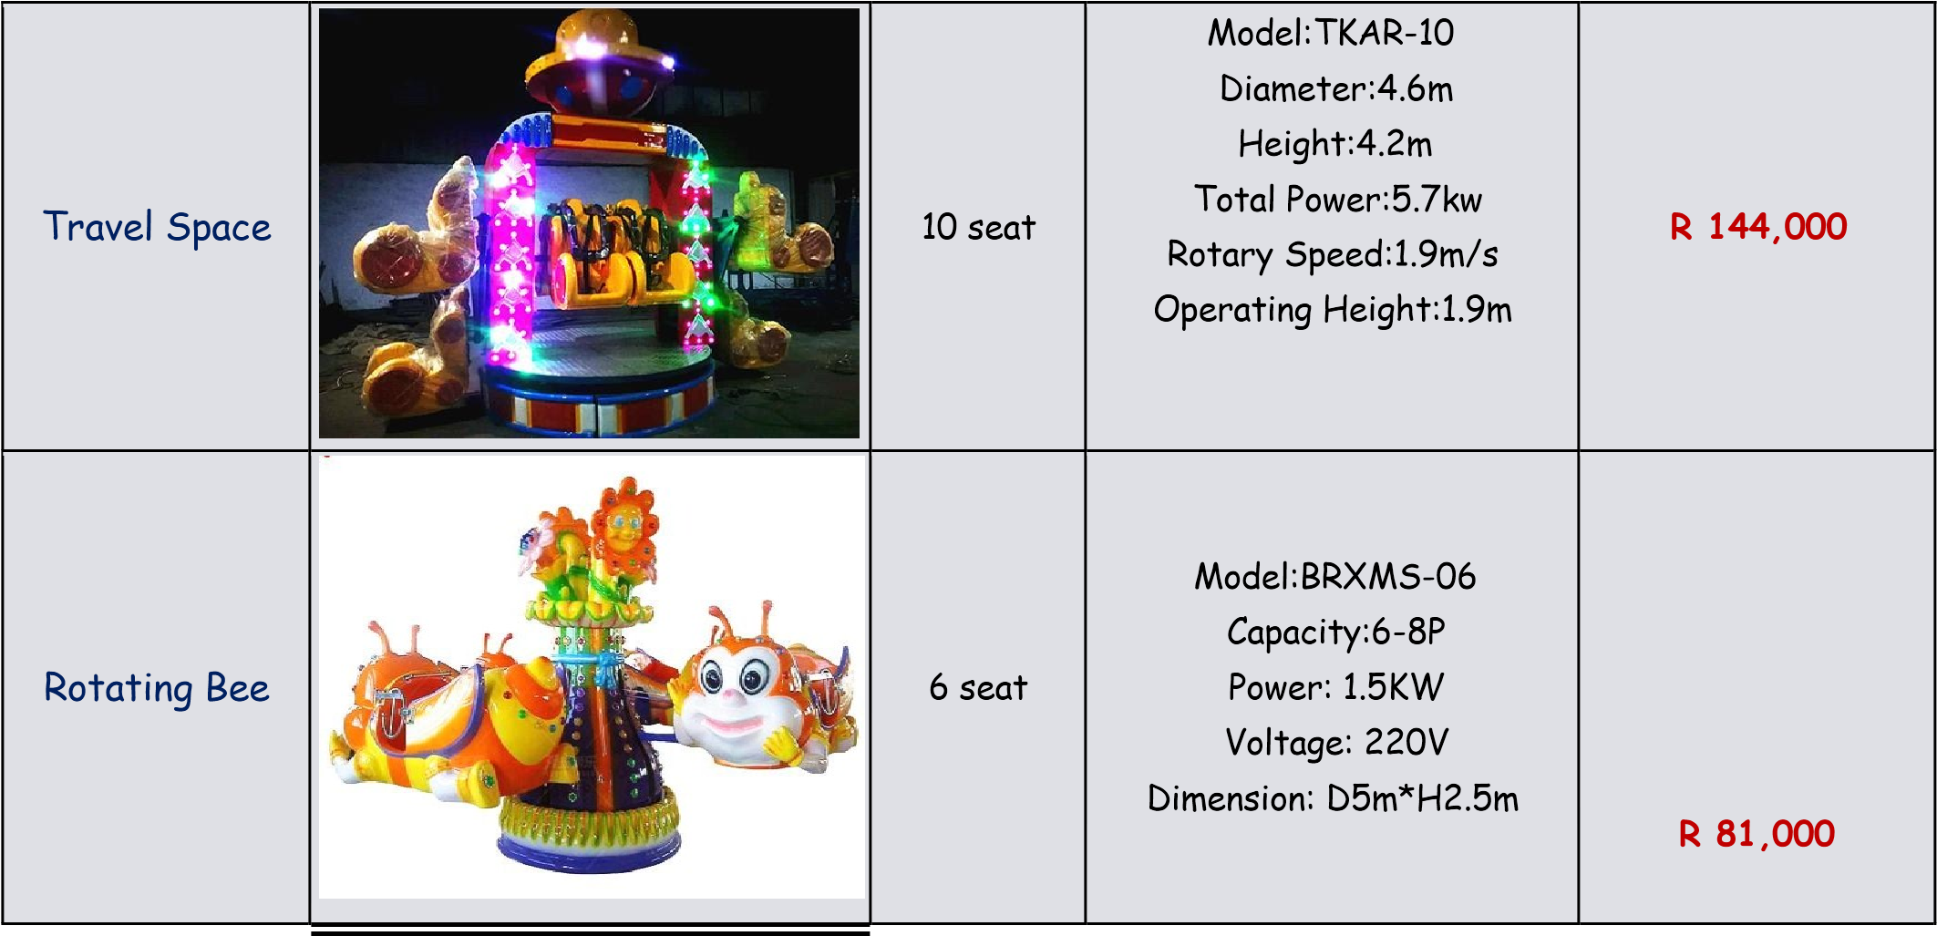

Self-control bees | 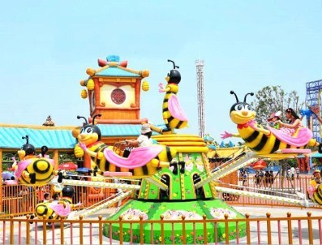 | 16 seat | Model:RKMF-16  Capacity: 16P  Power: 380V  Size:D8*H4m  Space area: 10*10m Weight: 3000kgs | R 132,000
Swing Elephant | 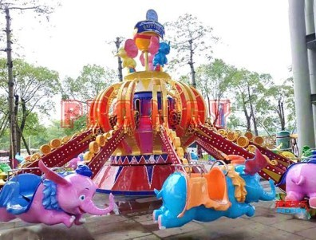 | 16 seat | Model:RKFX-16  Capacity: 16P  Power: 12KW  Voltage: 380V  Speed: 5rpm  Dimension: D9.4m*H6.5m Weight: 3500kgs | R 207,000
Coffee Cup | 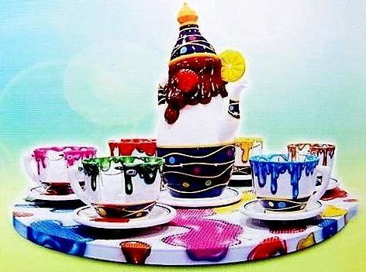 | 24 seat | Model:RFB-24  Capacity: 24P (6cabins)  Power: 9KW  Voltage: 380V  Dimension: D9m*H3m | R 127,500
Coffee Cup | 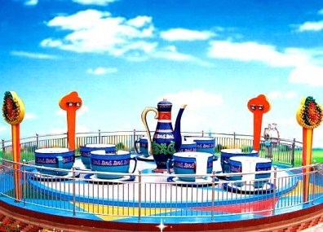 | 36 seat | Model:YFB-36  Capacity: 36P (9cabins)  Power: 13KW  Voltage: 380V  Dimension: D12m*H3m | R 382,500

Fruit Track  Train | 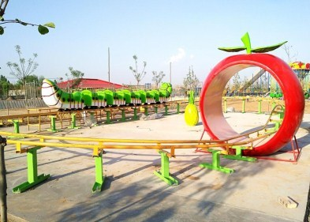 | 12 seat | Model:RGHC-12  Voltage:380V  Power:6kw  Longth of the track:60 m  Dimension:14m*10m Capacity:12seat | R 123,000
Snail Mini Roller  Coaster | 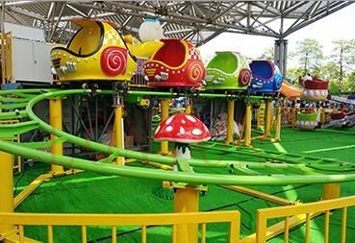 | 12 seat | Model：WNTC-20  Capacity: 20P(5 cubins)  Power: 18KW  Voltage: 380V  Dimension:22m*12m | R 495,000
Small Roller  Coaster | 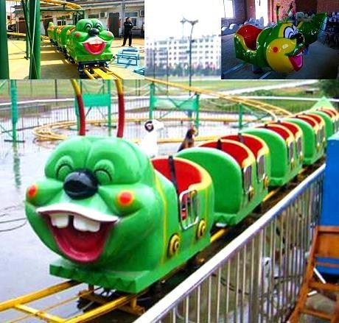 | 16 seat | Model:RCHC-16  Capacity: 16P  Power: 5KW  Voltage: 380V  Dimension:W10m*D15m*H2.  8m | R 262,500
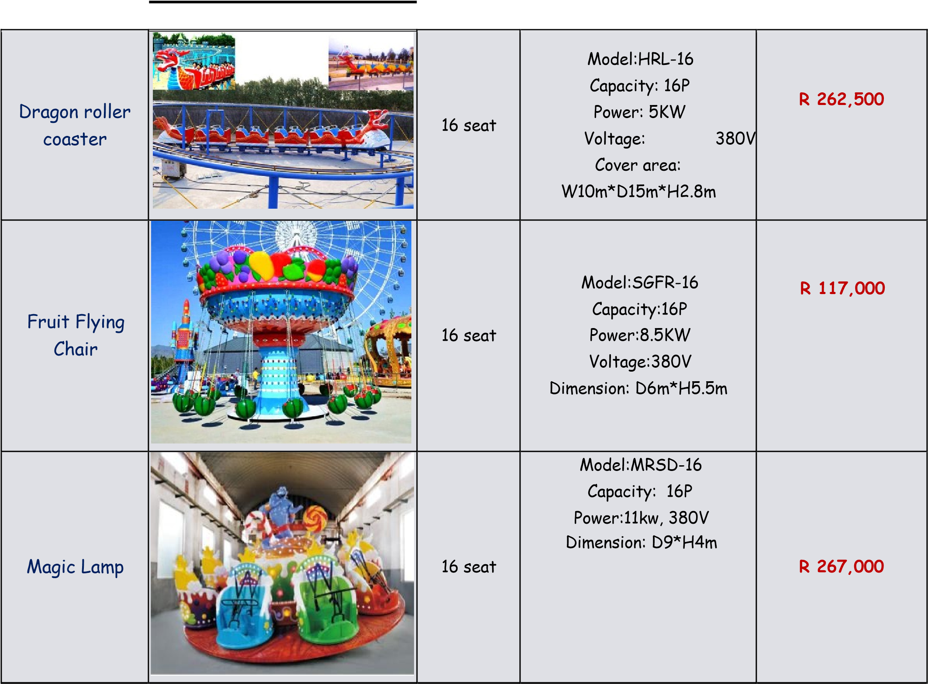
Star Trek | 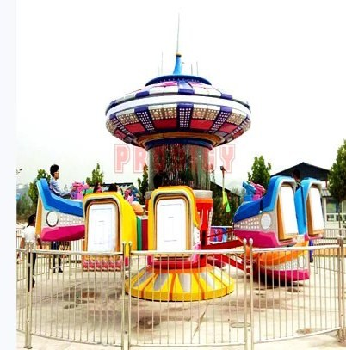 | 24 seat | Model:XRMH-24  Material:FRP + GB steel  Capacity: 24P  Power:18kw  Voltage:380V  Dimension:D10m*H6m | R 625,500
Octopus Ride | 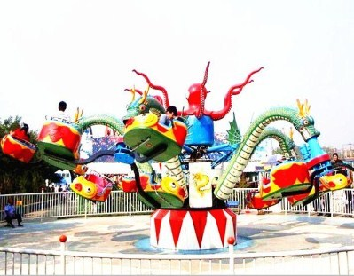 | 30 seat | Model:DRY-30  Capacity:30P  Power: 25KW 380V  Weight:8T  Speed:5.5-8.5rpm  Cover area:15m diameters Height:5.5m | R 330,000
Modern Times | 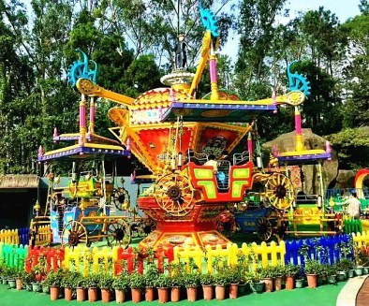 | 16 seat | Model:RDSD-16  Dimension:10 m  Capacity:16 seat  Height:6m  Power: 13KW Voltage:380V | R 302,250
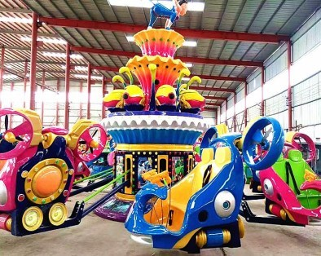
Blue Star |  | 16 seat | Model:LSRQ-16  Capacity：16P  Volt/Power：380V 12KW  Cover area：D11m  Dimension：D9.5m *H4.6m  Weight：3526KGS | R 301,500
Jumping Frog | 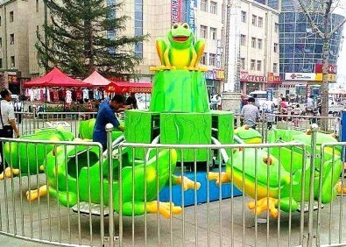 | 12 seat | Model:TTRW-12  Capacity:12P  Power: 7.5KW (6arms) Voltage:380V Dimension:  D6.5*H3.8m(6arms) | R 112,500
Jumping Kangaroo | 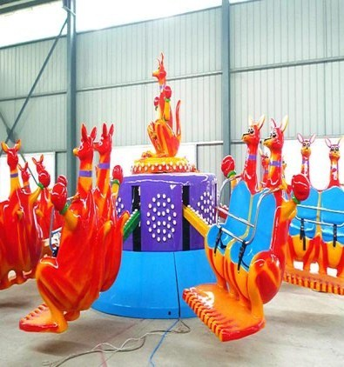 | 12 seat | Model:DRT-12  Capacity:12P  Power: 7.5KW (6arms) Voltage:380V Dimension:  D6.5*H3.8m(6arms) | R 112,500

Marine Battle | 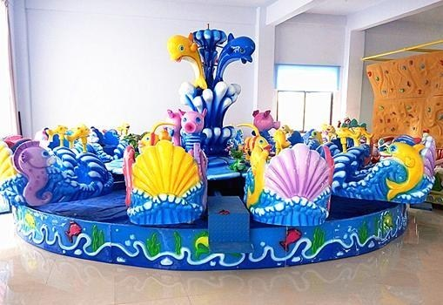 | 12 seat | Model:HYJR-12  Dimension:7m  Height:3.6m  Power: 5KW  Voltage:380V | R 192,000
Snails Rides | 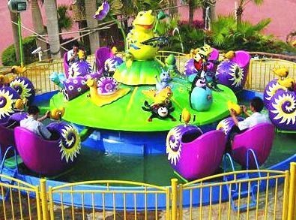 | 12 seat | Model:WNTRD-12  Dimension:7m  Height:4m  Power: 5KW  Voltage:380V | R 168,000
Crazy Dancing  Car | 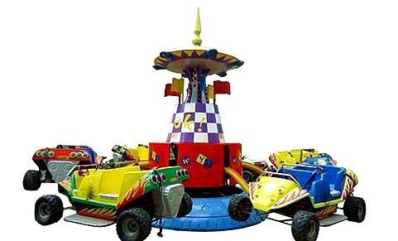 | 24 seat | Model:KCFR-24  Capacity: 24P / 32P  Power:8.5kw 380v  Speed:5.5rpm  Area:D8m*H3.2m(6cars  24P) D10m*H3.2m(8cars  32P) | R 232,500
Shark Island | 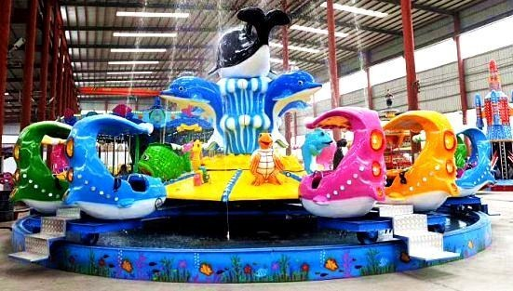 | 24 seat | Model:FRSYD-24  Dimension: D9.5*H4.2m  Power: 16KW  Capacity:24 seat Voltage:380V | R 253,500
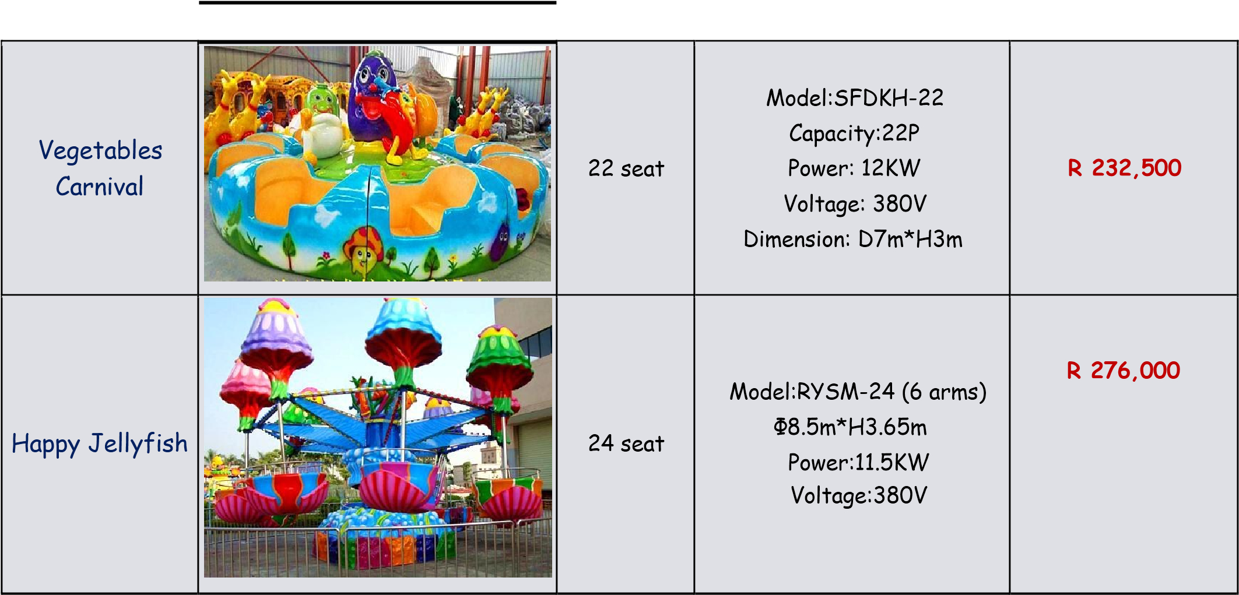
Ferris Ring Car | 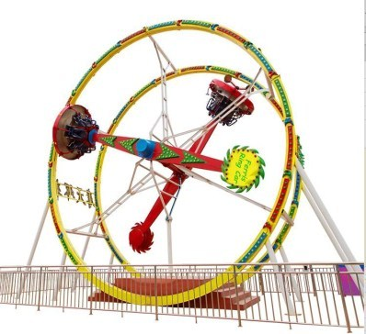 | 12 seat | Model：MTTRC-12  Voltage:380V  Power: 16 kw  Dimension 12*9(m)  Capacity:12 seat  Height:10m  Rotated Degree: 360 degrees | R 382,500
Samba Ballon | 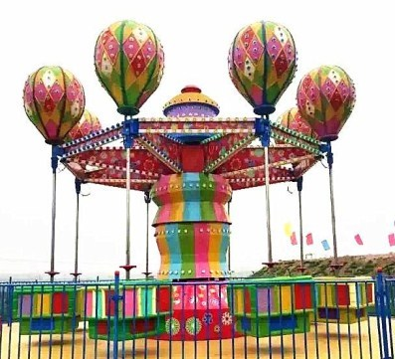 | 24 seat | Model:SBRR-24  Power:7.5KW  Voltage:380V  Dimension: D8m*H3.8m | R 237,000
Crazy Car | 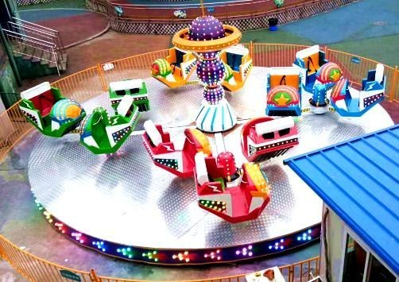 | 24 seat | Model:JRFW-24  Capacity: 24P(12cabins)  Power: 11KW  Voltage:380V  Diameter: 10m | R 315,000
Break Dance | 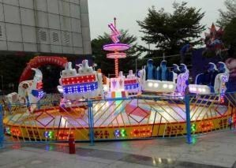 | 24 Seat | Model:PLRP-24  Material：FRP+steel .Power  Volt:380V  Power:16KW  Capability：24 persons  Area:12m*12m Height：2.5m | R 345,000
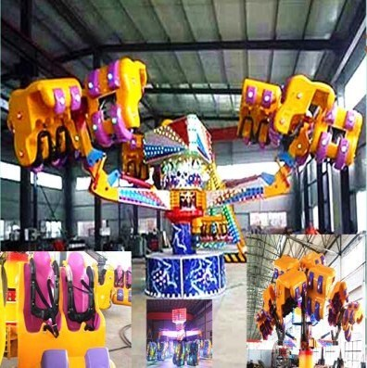
Energy Claw |  | 40 seat | Model:MSRB-40  Capacity:40P  Power:40KW  Voltage: 380V Dimension:  L18m*W18m*H4.5m | R 577,500
36 Seats  Luxury Carousel | 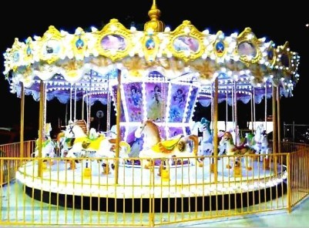 | 36 seat | Model:RBT-36  Capacity：36P  Voltage:380V  Power：15KW  Diameter:12m  Height：6.8m | R 624,000
Double deck  Carousel | 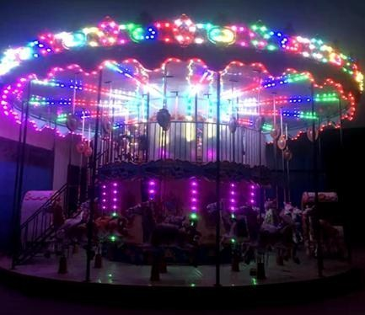 | 36 seat | Model:HPGRM-36  Voltage:380V  Power:11kw  Diameter:10m  Height:8.5 m  Capacity:36eat | R 832,500
Big pendulum  (under  transmission) | 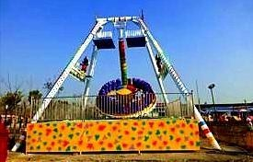 | 24 seat | Model:DBCR-24  Capacity:24P/Power: 25KW  Voltage:380V  Height:10m  Swing angle 90-120degree  Cover area:12*11m Operating Diameter:14m | R 486,000
Double flying | 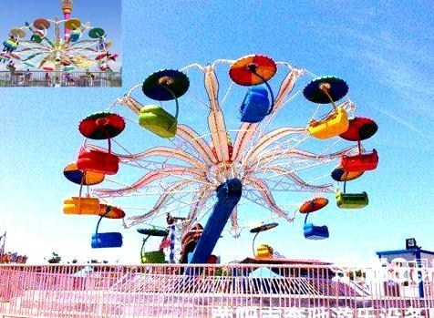 | 24 seat | Model:MRST-24  Capacity:24P Power:22KW 380V  Height:12m  Speed:2.2m/rps Cover Area:16*17m | R 277,500
Jumping Frog | 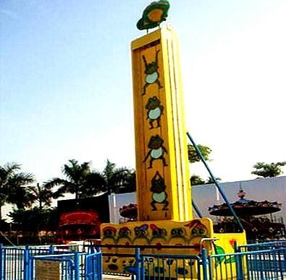 | 6 seat | Model:RWT-06  Capacity: 6P  Power: 12KW  Voltage:380V  Height: 8.3m  Lifting height:6m  Space area:5m*3m | R 250,500
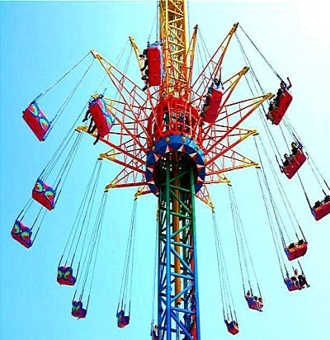
Flying tower |  | 36 seat | Model:FRK-36  Capacity: 36P  Power: 70KW  Voltage: 380V  Height: 40m  Space area: 26m*26m | R 2,905,500
Space-time shuttle | 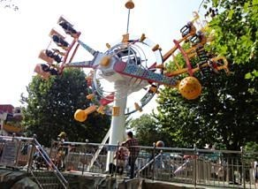 | 16 seat | Model:SKCR-16  Capacity：16P  Running height： 14m  Rotate D： 12m  Speed：《9rpm  Voltage：3N/380V/50HZ  Cover area：13m*9m | R 888,000
Drop tower | 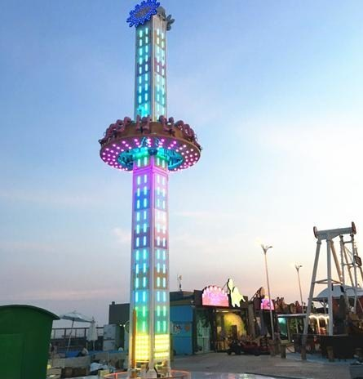 | 16 seat | Model:FRT-20 Capacity: 16seats  Height: 23m  Area:13*10m  Total Power:68KW  Speed:7.6m/s Running Height:18.7 | R 1,590,750
Flying UFO Ride | 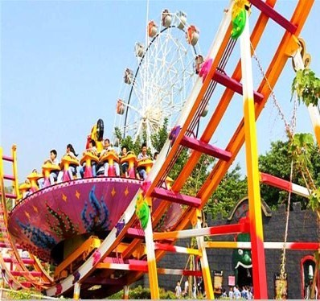 | 24 seat | Model:SRFD-24  Voltage:380V/Power:45kw  Dimension:10m*27m Capacity:24seat | R 654,750
Meniscus  Coaster | 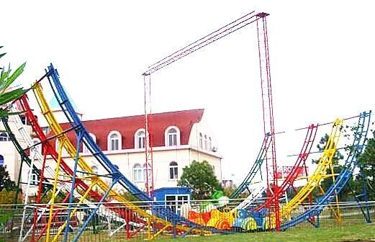 | 10 seat | Model:WRFC-10  Capacity: 10 seats  Height: 12 m  Area:22m*10  Total Power:12W  Speed:10m/s  5Sliding,5cars | R 483,000
Space-time shuttle | 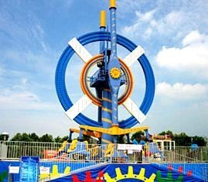 | 24 seat | Model:SKCRRT-24  Capacity：24P  Running height： 12m  Rotate D： 10.5m  Speed：《9rpm Voltage：3N/380V/50HZ  Power：75KW  Cover area：15m*10 | R 1,147,500

Big pendulum | 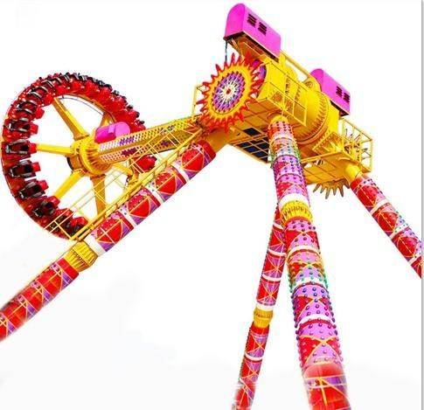 | 24 seat | Model:TDRC-24  Capacity:24P Power: 70KW 380V  Height:13m  Swing angle 90-120degree  Weight:15T  Cover area:20*15m | R 1,722,000

12m Ferris  Wheel | 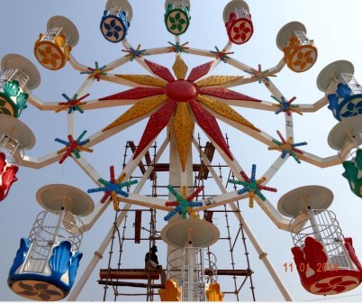 | 40 seat | CRL-12  Capacity:40P  Power: 5KW 380V  Total height:12m  Area:12*12m | R 462,000
20m Ferris  Wheel | 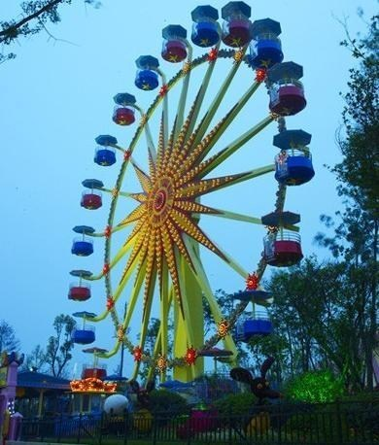 | 48 seat | CRL-20  Capacity:48P/12cabins  Power: 7.5KW/ 380V  Total height:20m  Wheel diameters: 18m  Area:17*14m | R 753,000
30m Ferris  Wheel | 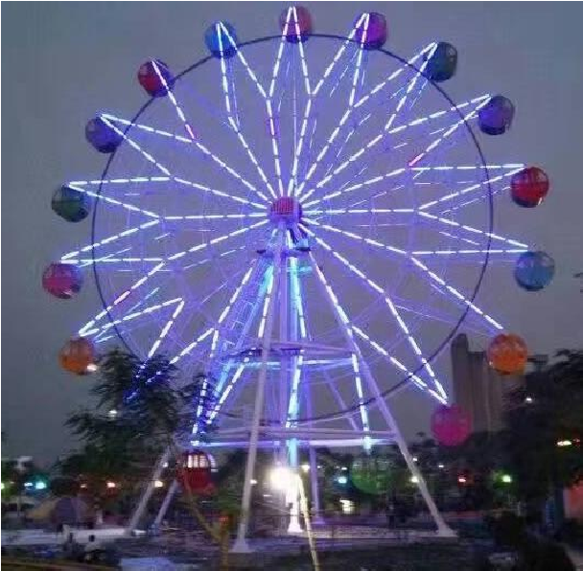 | 72 seat | Model:CRL-30  Capacity: 72P 18cabins  Power: 20KW 380V  Total height: 30m  Wheel diameters: 25.6m Cover area: 18m*20m | R 1,042,500
42m Ferris  Wheel | 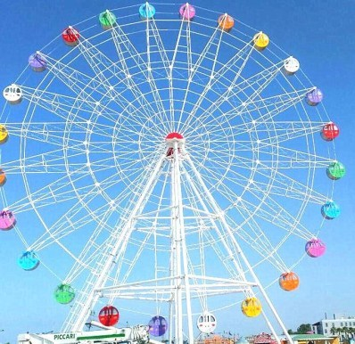 | 104 seat | Model:CRL-42  Capacity: 104P  26cabins  Power: 55KW /380V  Total height:42m  Cover area: 26m*24m | R 1,575,000
Customized product:Naught Castle
Style | Case Picture |  | Case Picture

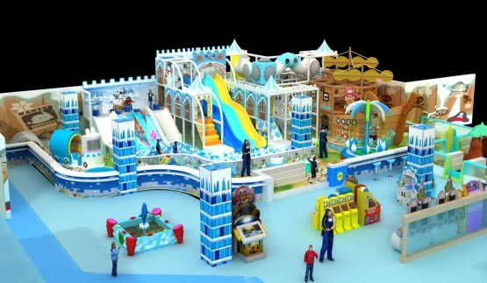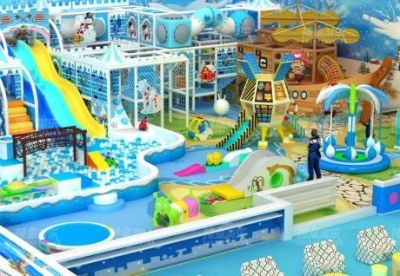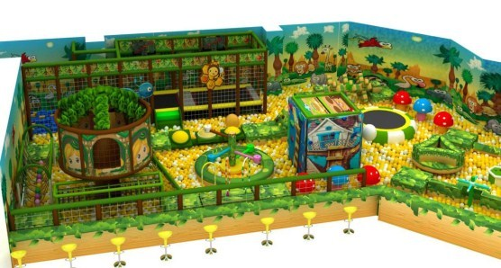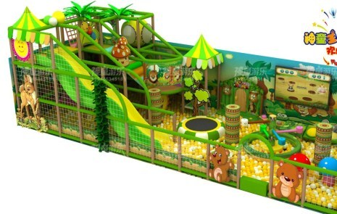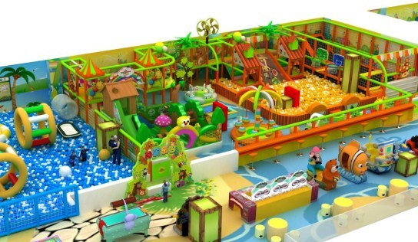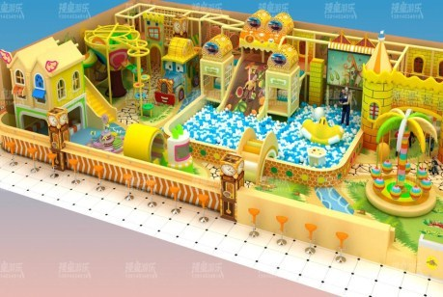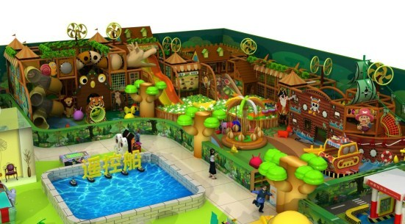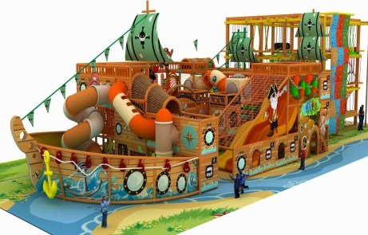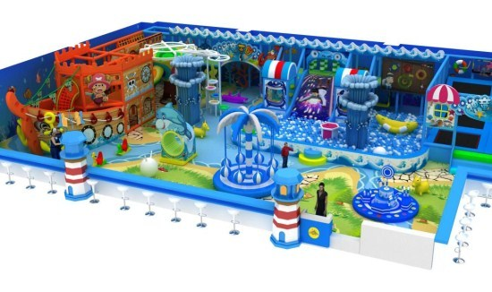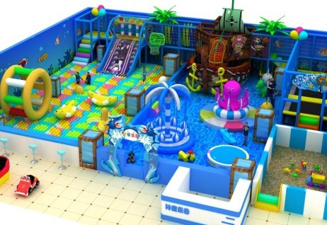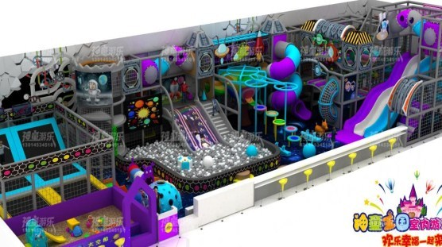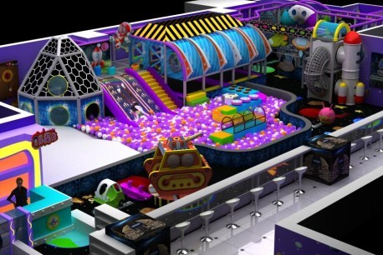

Ice

and

Snow

World

Recruit

Theme

Customized

Theme

Pirate

Ship

Theme

Ocean

Theme

Science

and

Technology

Theme

Forest  Theme | 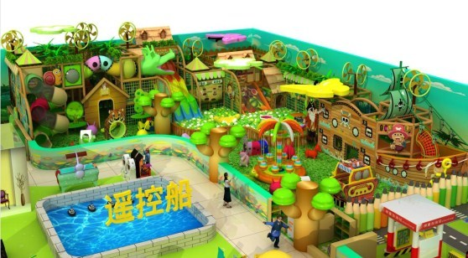 | 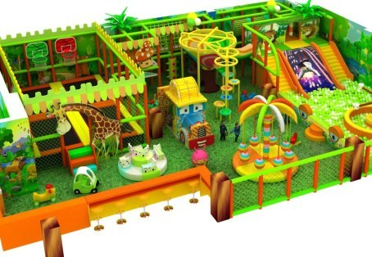
Sweets  Theme | 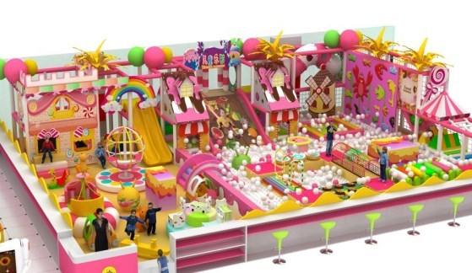 | 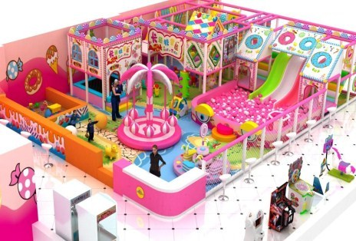
Outerward  Training Theme | 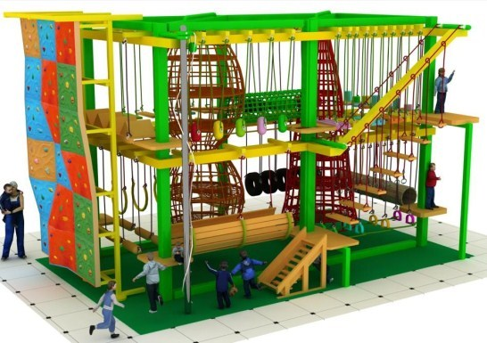 | 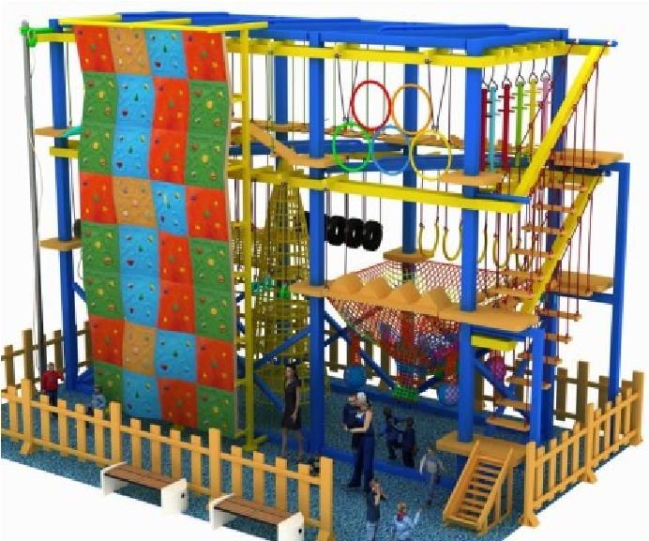
British  Theme | 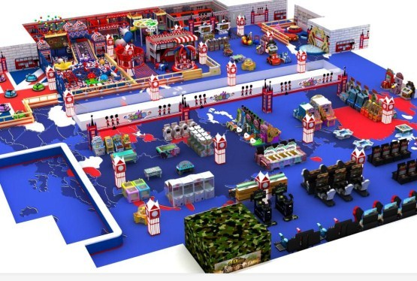 | 