Rumson Inflatables.
Jumping Castles Manufacturer Catalogue/Pricelist.

Email: sales@rumson-rides-inflatables.co.za Landline: +27-215-160-035
Website: www.rumson-rides-inflatables.co.za WhatsApp: +27-834-934-994

Product Name | Picture | Age Group | Description | Factory Price
Let's Party Playpark | 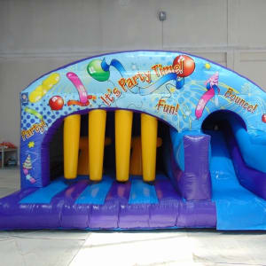 | Age less than 14 | Unit Size: 5.0mx5.0m x 3m | R 7,425
Super Hero Bouncy Castle & Slide | 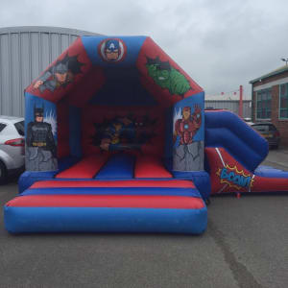 | Age Less than 14 | Unit Size: 4.8mx5mx4m | R 6,800
New lets party bounce and slide | 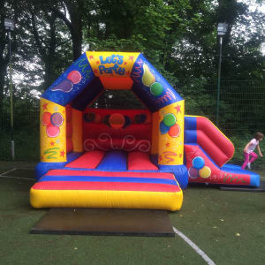 |  | Unit Size: 4.8m x 5.0m x 4m | R6,800
Inflatable Axe Throwing Game | 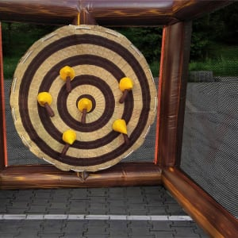 |  | If you have never thrown an axe fear not, our new attraction is similar to the classic pub game of darts, each player takes turns throwing axes tries to score the most points. You can either play with 2 players (each gets 5 throws), or with 4 players (each gets 3 throws). | R 10,000
Bouncy Castle and Rodeo Pumpkin | 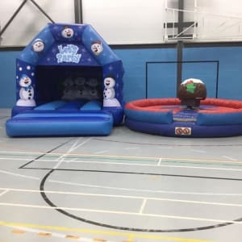 |  | One inflatable a deluxe built themed bouncy castle with the amazing hand painted artwork looks like its real and the children can bounce the day away with all there favorite characters. Rocking rodeo Pudding, suitable for all ages and creating a really festive scene for your event you will struggle to get people to leave, our amazing rocking Rodeo pudding will spin, duck and dive while your guests hold on to see who can be victorious and claim the office bragging rights. | R 18,000
Family Bouncer 2 | 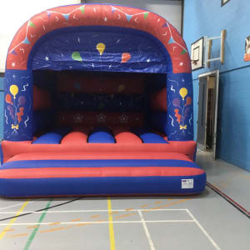 |  | Unit Size: 5m x 5m x 4.5m | R 10,000
Designer Castle & Slide | 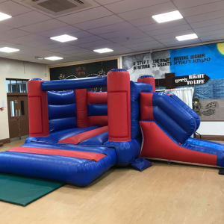 |  | Unit Size: 4m x 5m x 3m | R7,200
Candy Twist Dome | 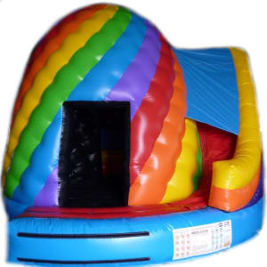 |  | Unit Size: 5m x 5m x 4m | R7,800
Indoor Jungle package COMBO | 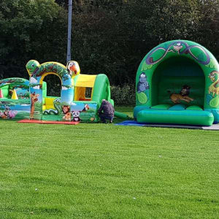 |  | Unit Size: 5m x 5m x 3m | R18,000
Pink and Purple Slide Bouncy Castle Designer | 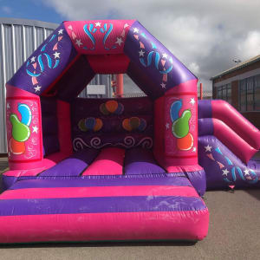 |  | Unit Size: 5m x 5m x 3m | R7,000
60ft Rain covered Assault Course | 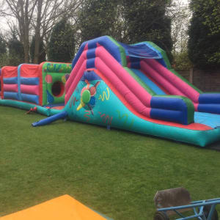 |  | Unit Size: 18m x 4m x 4m | R27,100
Beach Party | 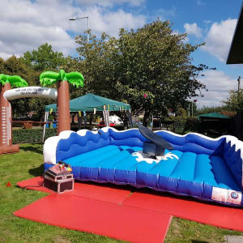 |  | Customized | R26,700
Event package 1 | 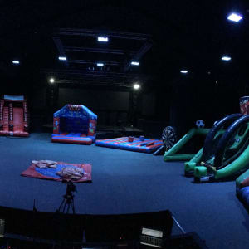 |  | Customized | R19,800
Big Slide & Hungry Hippo | 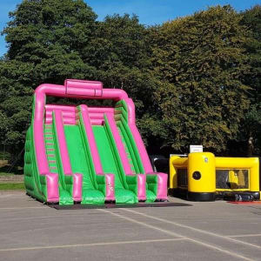 |  | Unit Size: 6m x 5m x 4m | R 26,700
Ninja Wall | 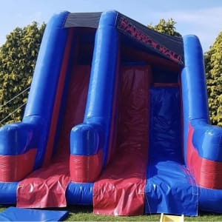 |  | Customized (standard size) | R20,100
Big Slide | 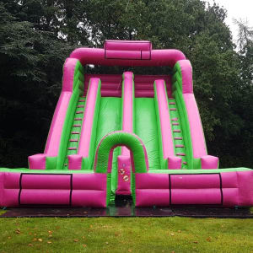 |  | Unit Size: 7.3m x 7m x 8.4m  Suitable for Adults &Children | R27,700
Velcro Celebration Slide | 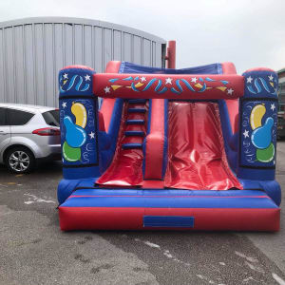 |  | Unit Size: 3.5m x 3m x 5.4m  Suitable for Children  Not suitable for Adults | R13,700
10ft platform Rush slide | 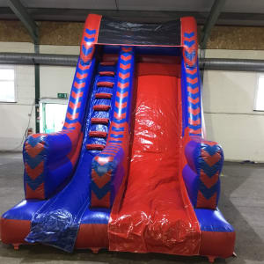 |  | Unit Size: 6m x 3m x 4m  Suitable for Adults &Children | R 15,800
Pink & Purple Balloon Slide | 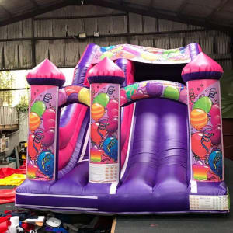 |  | Unit Size: 6m x 3m x 4m  Suitable for Adults &Children | R 12,900
45ft Celebration Assault Course Streamers | 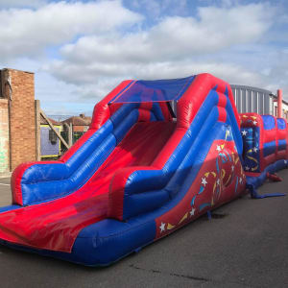 |  | Unit Size: 13.7m x 3m x 3.7m  Suitable for Adults &Children | R 38,800
Wedding Bouncy Castle | 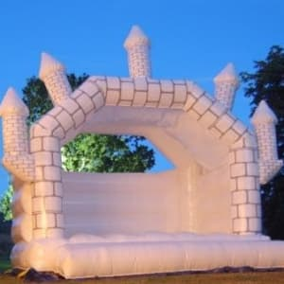 |  | Unit Size: 4.8m x 4.8m x 4.8m  Suitable for Adults &Children | R18,900
Adult Bouncy Castle | 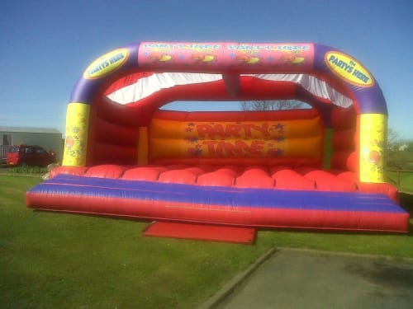 |  | Unit Size: 7.5m x 7.3m x 3.8m  Suitable for Adults &Children | R17,900
Indoor Designer Adult Bouncy Castle | 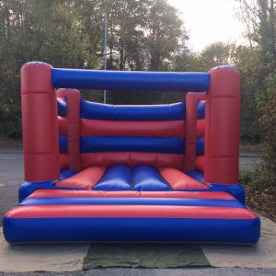 |  | Unit Size: 4.5m x 4m x 3m  Suitable for Adults &Children | R 16,980
Castle & Slide package COMBO | 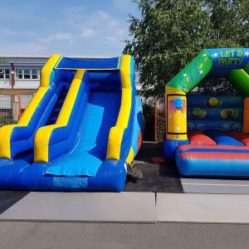 |  | Unit Size: 4.5m x 4m x 3m  Suitable for Children  Not suitable for adults | R20,700
School Bouncy Castle & Slide Package COMBO | 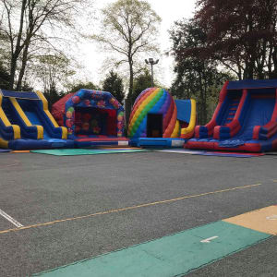 |  | 5 Jumping castles  Suitable for Adults& Children | R 49,999
Show Stopper COMBO | 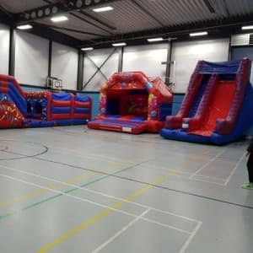 |  | 3 Jumping Castles  Suitable for Adults& Children | R 29,999
School Fun Day 3 | 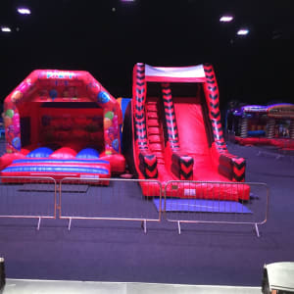 |  | 2 Jumping Castles | R21,999
Wrist band fun day package 5 COMBO | 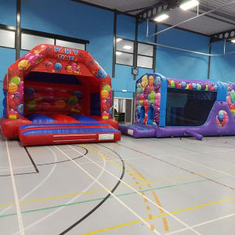 |  | 2 Jumping Castles | R19,999
Lets party indoor party package COMBO | 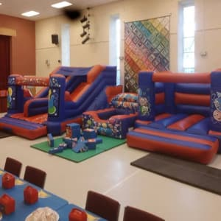 |  | 2 Jumping Castles | R 19,999
Super Hero Spiderman COMBO | 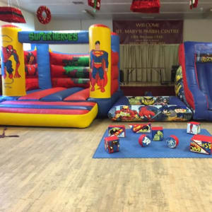 |  | 2 Jumping Castles | R 16,999
Toddler Package | 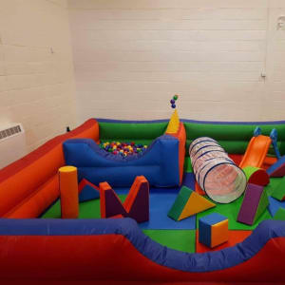 |  | Soft Play | R 4,200
Lets party package | 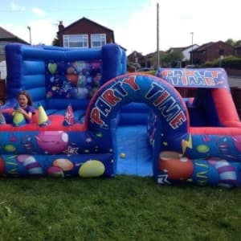 |  | Let’s party package COMBO deal has been put together for young children in mind and is perfect for any little boy or girls special day and it consists of the following:  Built in ball pool, air juggling game,mini bouncy castle and a small slide.  Soft play to match the play park.  Inflatable bouncy castle | R 14,000
Soft Play Rubix Cube | 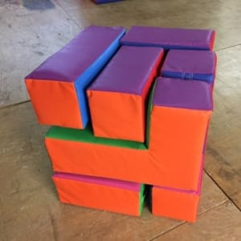 |  | Do you remember the classic Rubix cube game? Well here is a new and exciting twist to the classic game. This is an impressive soft play version can you race against the clock and assemble the cube back together making sure all the colors match up? | R 3,800
Ball Pool - 8ft | 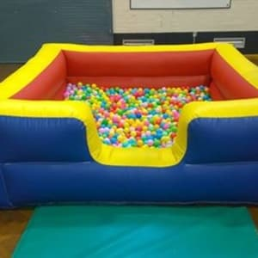 |  | This colourful,inflatable 8ft ball pool is perfect for little ones!  Our ball pools are perfect for big and small events and are a fantastic way to make sure the younger ones have something to play with!  Ball Pools are ideal for both indoor and outdoor use. | R 4,900
Toy Story Package | 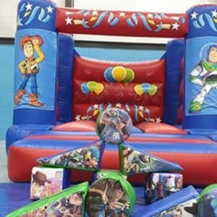 |  | Our package is tailored for young children who dream of playing with their favorite characters, let their imagination run wild with this brilliant set up | R 9,800
Princess Fairytale Delux Package | 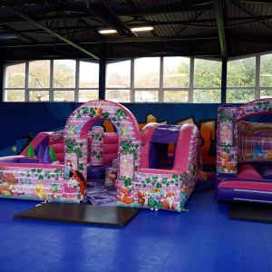 |  | Indoor inflatable 3x4m bouncy castle features a pink & purple colour scheme with amazing graffic art that really stands out and provides that wow factor at any little girls’ birthday.  Assorted Fairy tale soft play bricks. | R 11,000
Indoor Unicorn Party Package | 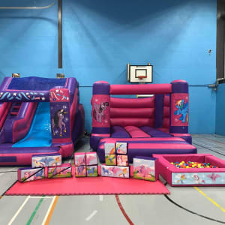 |  | Unicorn themed bouncy castle  Unicorn themed indoor slide  Unicorn themed ball pool  Unicorn themed soft play  Safety Mats | R 17,900
Deluxe Children's Disco Dome | 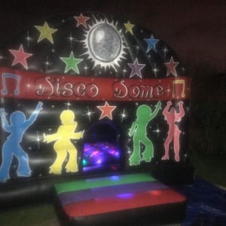 |  | Unit Size: 5.2m x 3.5 m x 3.5m | R 14,000
Velcro blue & red castle | 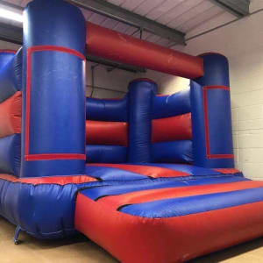 |  | Unit Size: 3.2m x 3m x 3.6m | R 7,000
Adult lets party Blue bouncy castle | 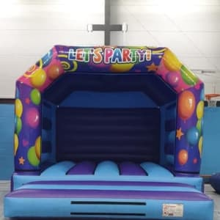 |  | Unit Size: 4.8m x 4m x 3.6m | R 9,700
Giant slide & Assault Course Package | 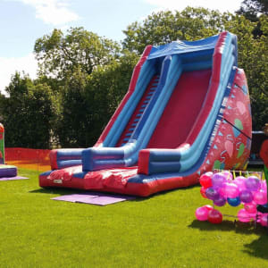 |  | Unit Size: 5m x 6m x 4m | R 38,000
Inflatable Snow Globe | 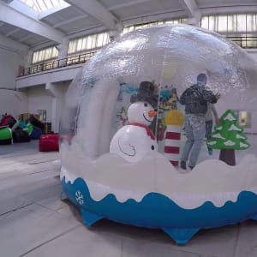 |  | The Giant Snow Globe is large enough to fit up to 4 adults, who enter via the special air-lock at the back. | R 10,000
150ft Assault Course | 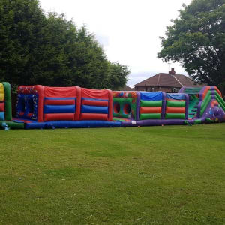 |  | WOW here we have a real show stopper it’s the south Africa’s first 45.7m assault course. This fantastic inflatable will have you racing through squeeze tubes, fighting the biff bash bed, on your belly crawling through the camo style netting and down a 2m tall platform slide. Perfect for sports day’s, fun day’s, corporate day's or any event really. Please note that colors may vary. | R 56,700
3 Laned Adult Assault Course | 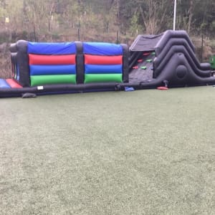 |  | Unit Size: 15m x 5m x 3m | R 35,000

